**INDIA'S AGRICULTURE CROP PRODUCTION ANALYSIS**

1. **INTRODUCTION:**

**1.1 Overview**

Analyzing India's agricultural crop production involves a comprehensive understanding of the historical, economic, and ecological factors that influence this sector. Agriculture plays a pivotal role in India's economic development, food security, and livelihoods, making it essential to address challenges and embrace sustainability for the sector's long-term success.

**1.2 Purpose**

In summary, the analysis of India's agriculture crop production serves a broad spectrum of purposes, ranging from food security and economic development to resource management and sustainability. It provides insights for policymakers, researchers, and stakeholders to make informed decisions and take actions that support the well-being of the nation and its people.

1. **PROBLEM DEFINITION AND DESIGN THINKING:**

**2.1 Empathy map**

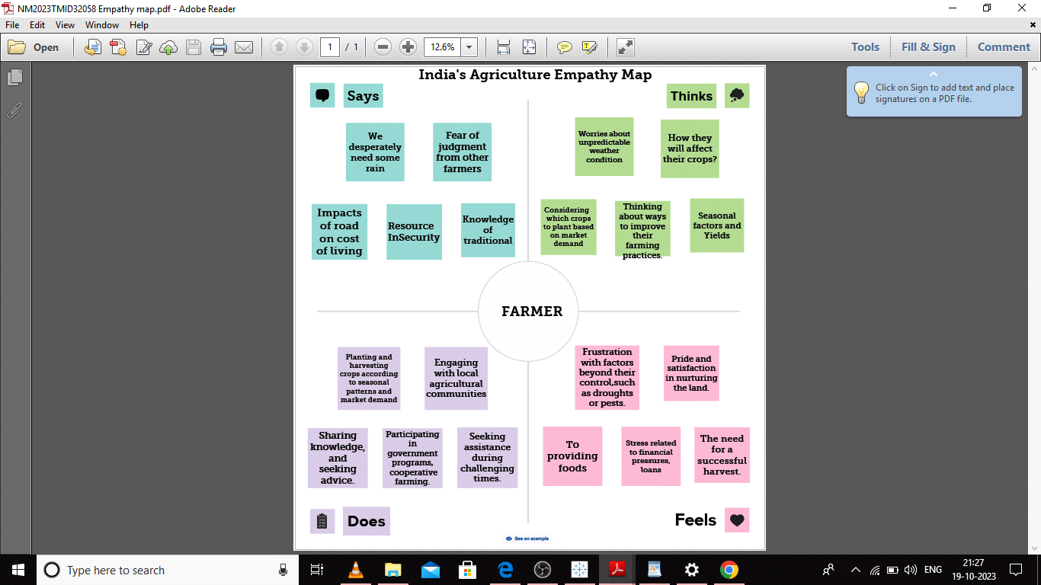

**2.2 Ideation and Brainstorming Map**

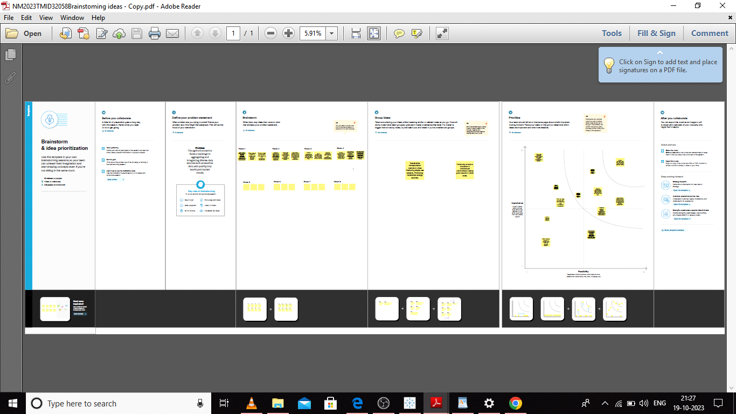

1. **RESULT**

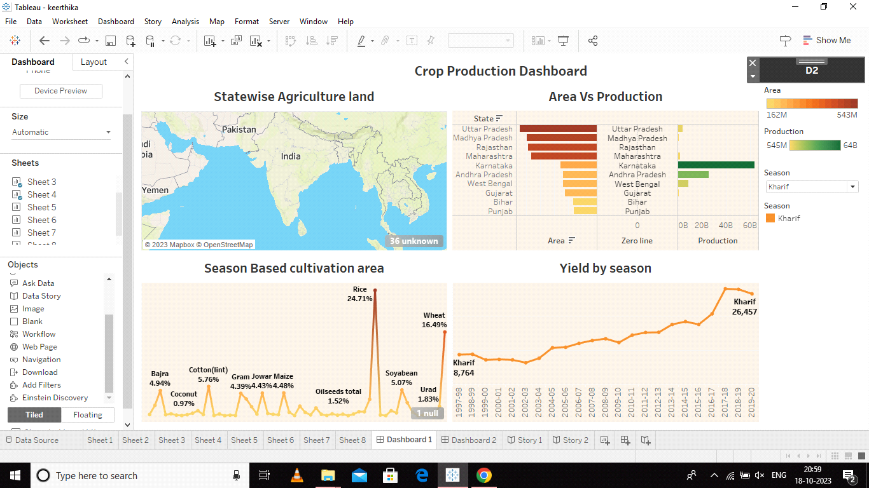

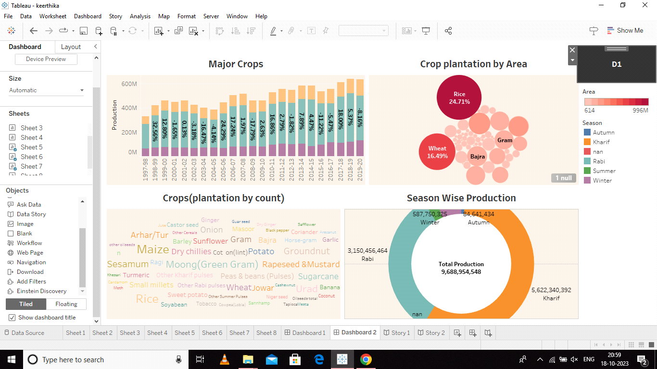

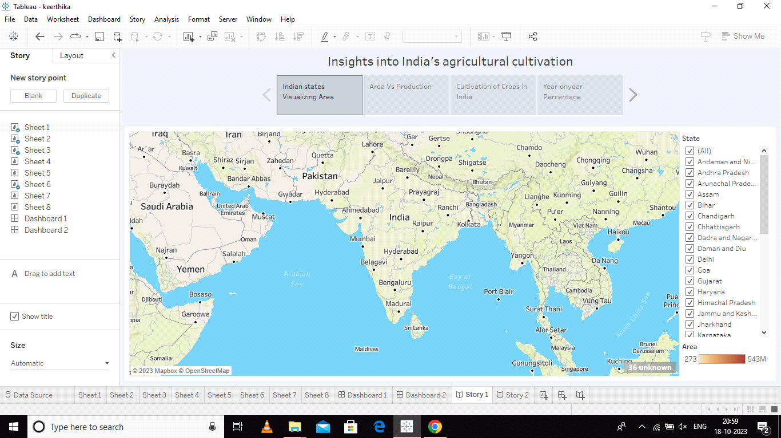

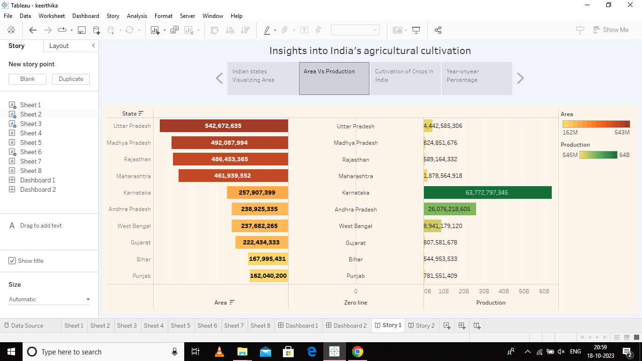

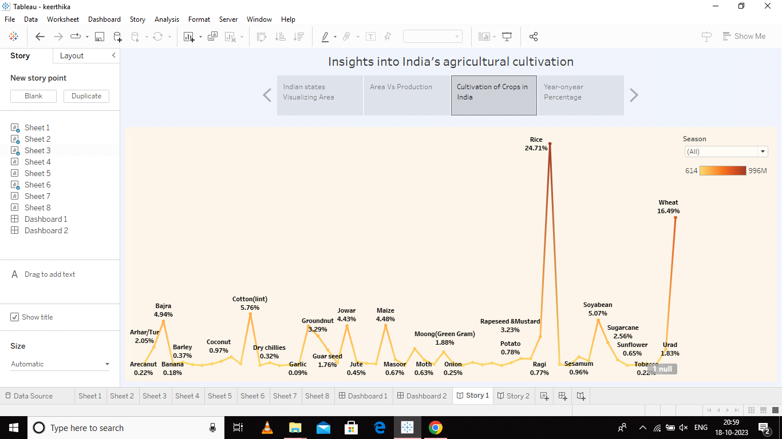

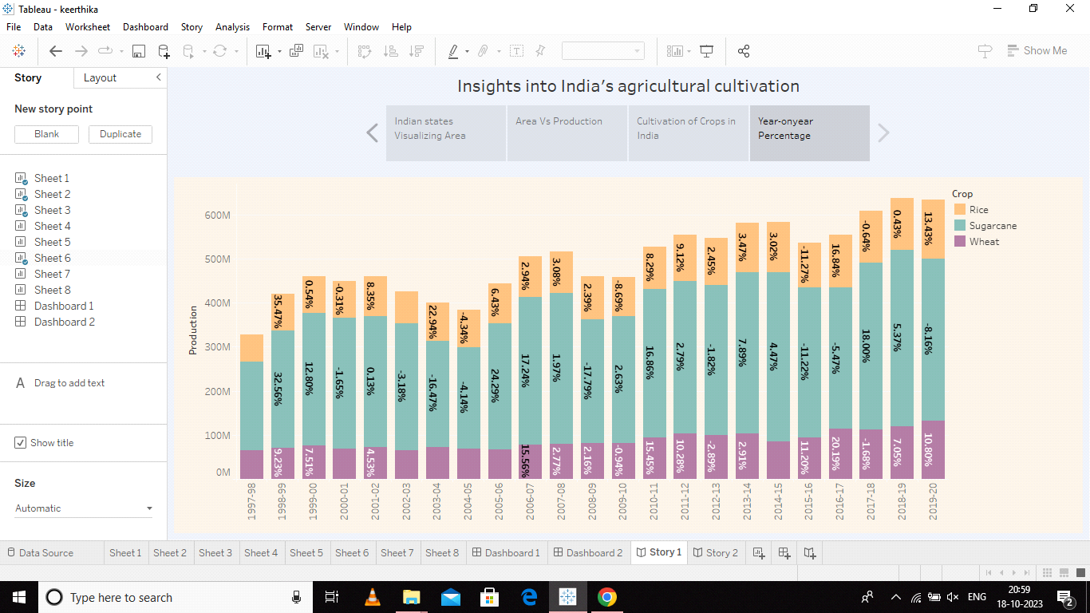

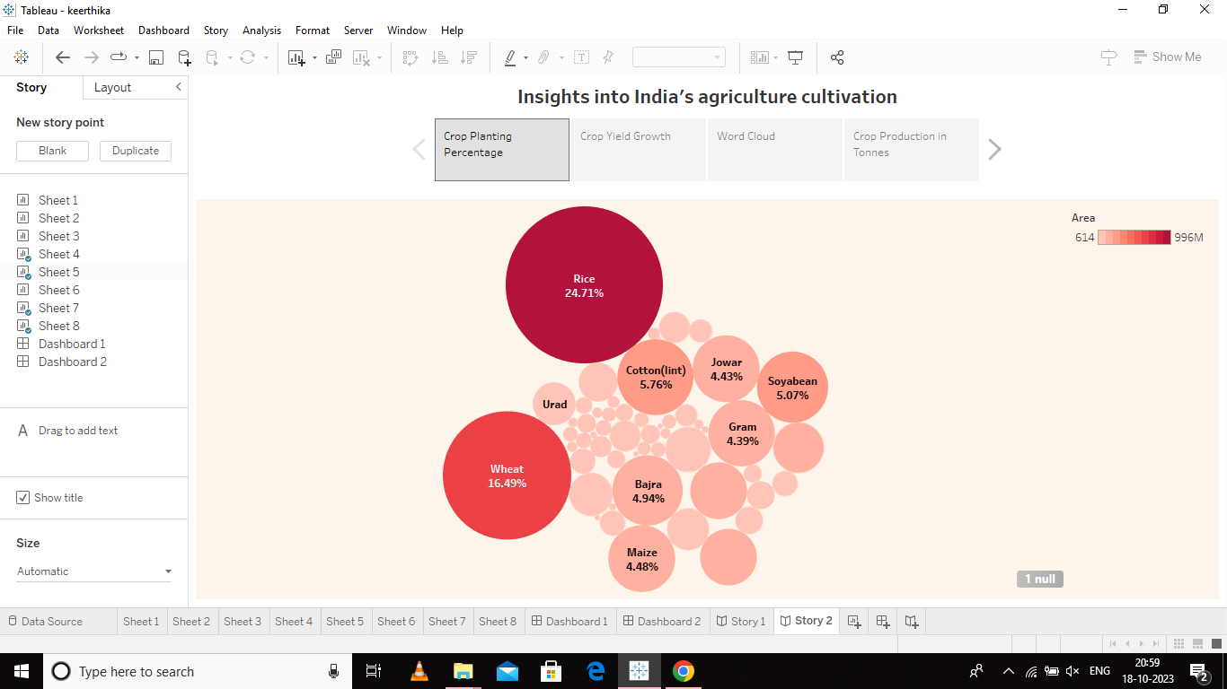

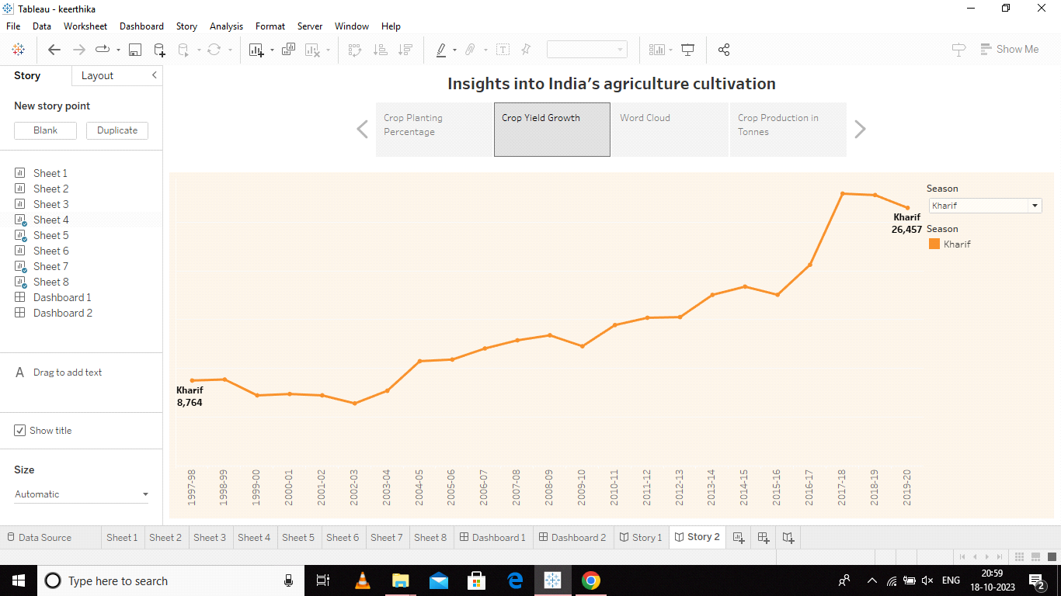



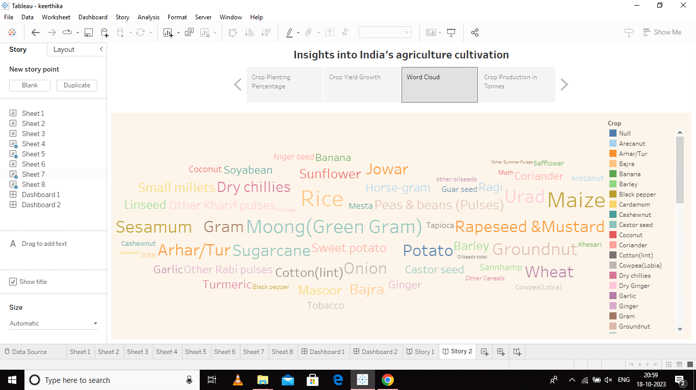

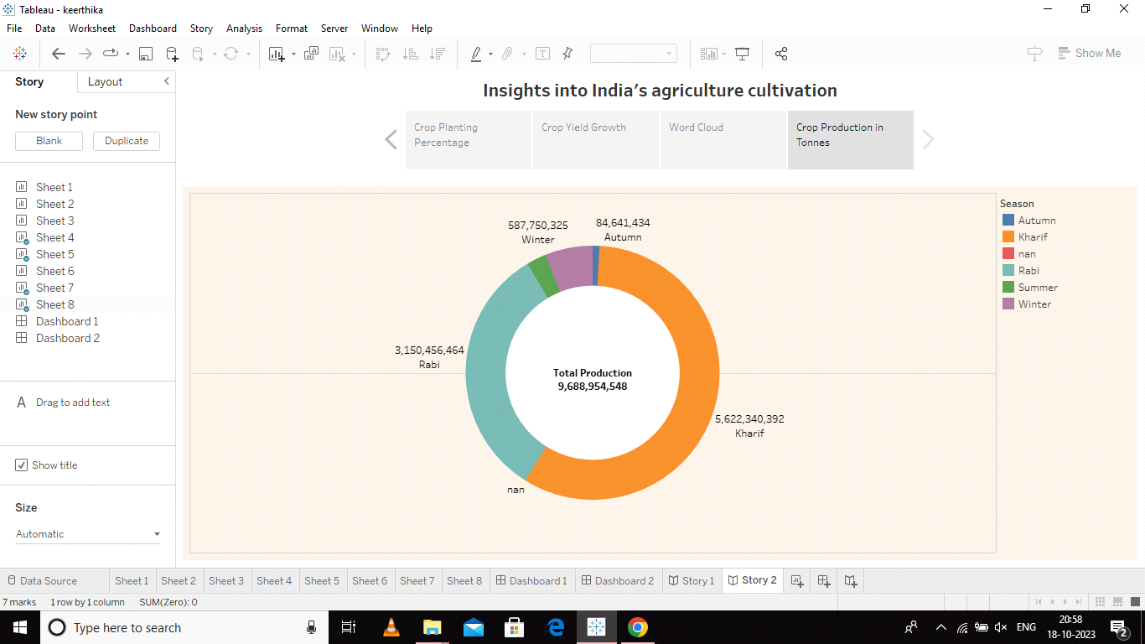

**4.1 ADVANTAGES**

**Food Security:**

Crop production analysis helps ensure a steady and sufficient food supply, reducing the risk of food shortages and enhancing food security for the nation.

**Economic Growth:**

It contributes to the growth of the agricultural sector, which is a vital component of India's economy. Increased agricultural productivity can boost GDP and provide income for millions of people.

**Efficiency:**

By identifying areas with low crop yields or high losses, crop production analysis can highlight inefficiencies in the agricultural process, prompting the adoption of more efficient and sustainable farming practices.

**Risk Mitigation:**

By monitoring crop production trends and climate conditions, it allows for better preparation and risk mitigation strategies for dealing with natural disasters or extreme weather events, which can severely impact agriculture.

**Research and Development:**

Researchers can use crop production data to conduct studies and experiments aimed at improving crop varieties, disease resistance, and overall agricultural practices.

**Market Access:**

Crop production analysis helps identify areas where improved infrastructure and market access are needed, allowing farmers to reach a broader consumer base and improve their income.

**Transparency:**

It fosters transparency in the agricultural sector by making production data available to all stakeholders, including farmers, policymakers, and consumers.

**4.2 DISADVANTAGES**

**Data Inaccuracies:**

Data collection in agriculture can be challenging, and inaccuracies in data can lead to incorrect assessments of crop production, which can have implications for policy and decision-making.

Data Gaps:

There may be gaps in data collection, particularly in remote or less-developed regions, which can hinder a comprehensive analysis of crop production.

**Resource Intensive:**

Collecting, managing, and analyzing agricultural data can be resource-intensive, requiring funding, technology, and skilled personnel. Inadequate resources can limit the scope and quality of analysis.

**Timeliness:**

Timely data is critical for decision-making, but delays in data collection and reporting can impact the effectiveness of crop production analysis, particularly in fast-changing conditions.

**Data Interpretation**:

Interpreting agricultural data and translating it into actionable insights may require expertise. Misinterpretation of data can lead to inappropriate policy decisions.

**5 APPLICATIONS**

In India has a wide range of applications that benefit various stakeholders, including government bodies, farmers, researchers, policymakers, consumers, and international organizations. It plays a crucial role in addressing food security, economic development, and sustainability in the agricultural sector.

**6 CONCLUTION**

This analysis is essential for various purposes, including ensuring an adequate food supply, formulating effective agricultural policies, and managing natural resources responsibly. It also guides rural development, empowers farmers, and informs research and development initiatives aimed at improving crop varieties and farming practices.

While there are challenges associated with data accuracy, resource constraints, and political influence, the benefits of crop production analysis are significant. It plays a crucial role in addressing food security, supporting economic growth, and promoting sustainable and environmentally responsible agricultural practices.

**7 FUTURE SCOPE**

The future scope of analyzing India's agriculture crop production is dynamic and driven by technological advancements, climate change, sustainability goals, and the need to support farmers and ensure food security. As data collection and analysis methods continue to evolve, the potential for addressing complex agricultural challenges and opportunities in India remains promising.